Lazy Dog Guitars

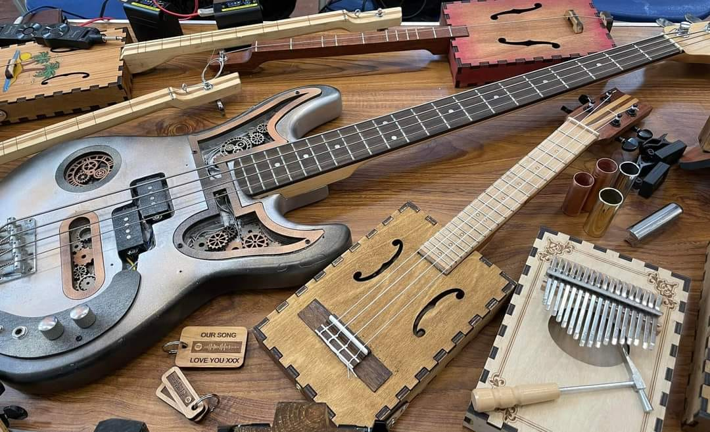

What are Cigar Box Guitars ?

The cigar box guitar is a simple chordophone that uses an empty cigar box as a resonator. The earliest had one or two strings; modern models typically have three or more. Generally, the strings are connected to the end of a broomstick or a 1×2 inch wood slat and to the cigar box resonator.

Trace evidence of cigar box instruments exists from 1840 to the 1860s. The earliest known illustration of a cigar box instrument is an etching copyrighted in 1876 of two American Civil War soldiers at a campsite, one of whom is playing a cigar box fiddle.

A modern revival of these instruments has been gathering momentum with an increase in the number of cigar box guitar builders and performers. A loose-knit group of underground musicians tour the East Coast of the United States each summer under the banner "Masters of the Cigar Box Guitar Tour"

Tuning
Many different tunings can be used for cigar box guitars. Common tunings are
- Open tuning
- A – e – a or G – d – g
- A – e – a – c#' or G – d – g – b
- Classical
- A – d – g
- d – g – b – e
- Hawaiian tuning:
- A – e – f#
- Four string banjo tuning:
- D – G – b – d
Notable Performers
- Bo Diddley
- Billy Gibbons of ZZ Top
- Seasick Steve
- Ed King of Lynyrd Skynyrd
- Paul McCartney
- Samantha Fish
- Justin Johnson
- Jimi Hendrix
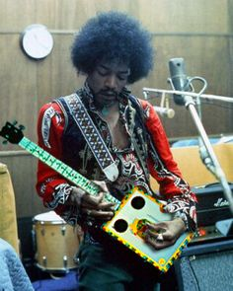

Lazy Dog Guitar (Example builds)

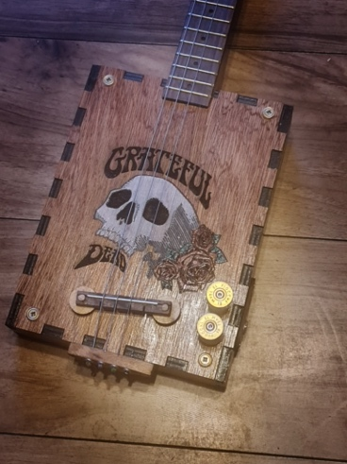 | 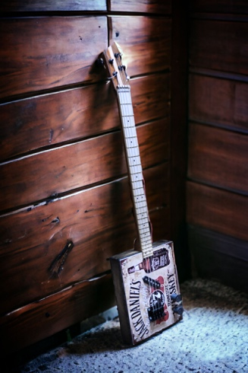 | 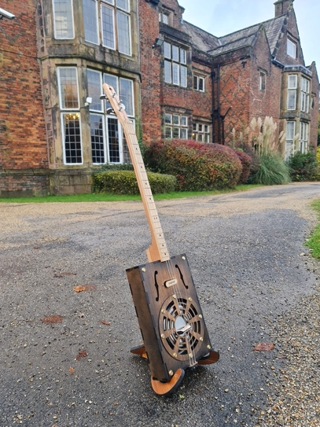
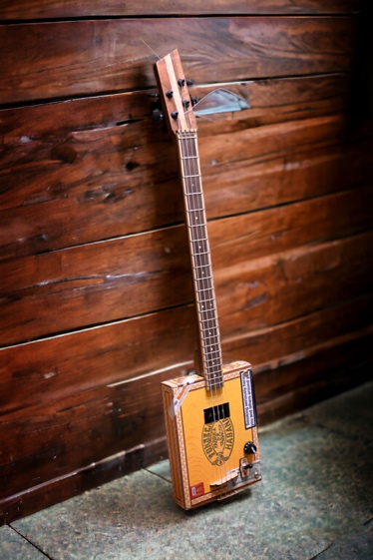 | 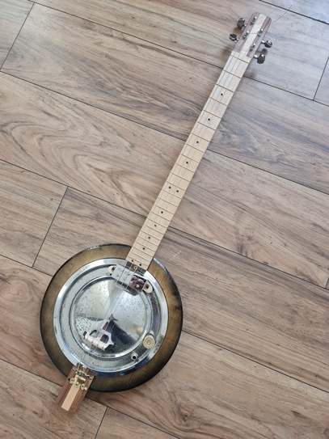 | 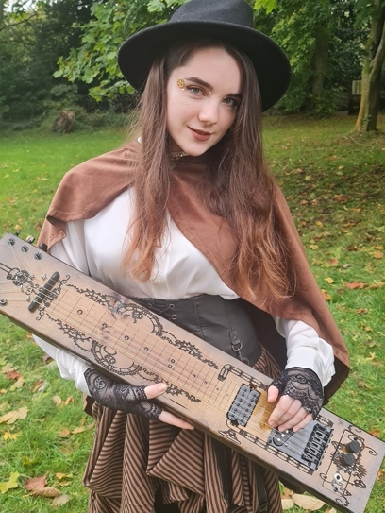
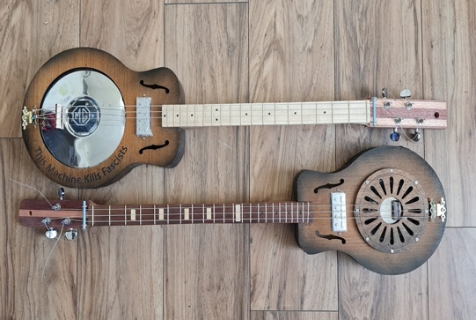 | 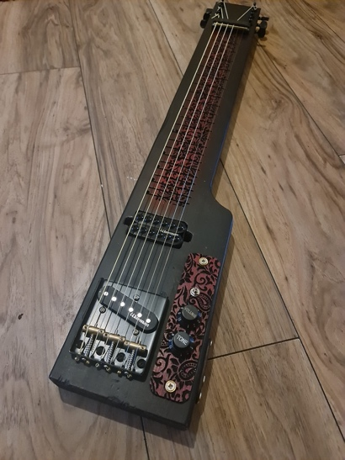 | 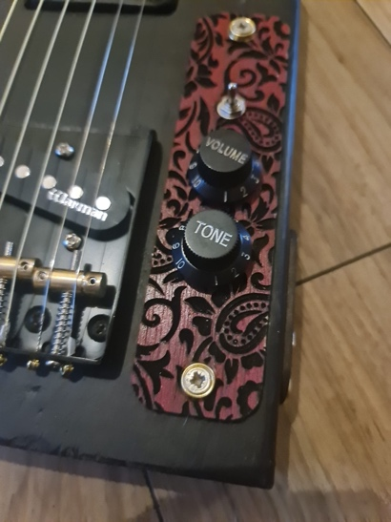

Traditional style Cigar Box Guitars
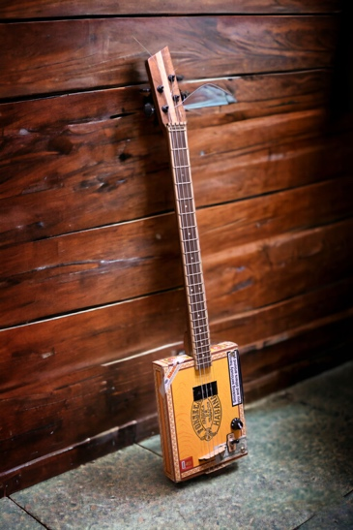
Our Cigar Box guitars are hand built using used cigar box cases, these vary greatly in design – depending on stock (which is obviously getting shorter now !) Generally built with Three or Four strings we can supply them with a variety of neck designs, pickups and hardware – see our order section for options.
Box style guitars
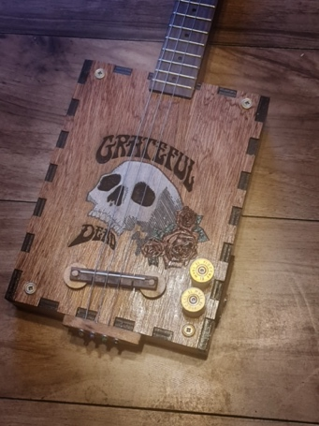
Following the ethos of the cigar box guitar, these guitars, again, are generally built with three or four strings, however they use a custom built box – hand made using hardwood ply, this allows the customer to not only specify it’s dimensions but also allows custom engraving and / or painting to be applied to give a truly unique product. Again we can supply them with a variety of neck designs, pickups and hardware – see our order section for options.
Lap Steel Guitars
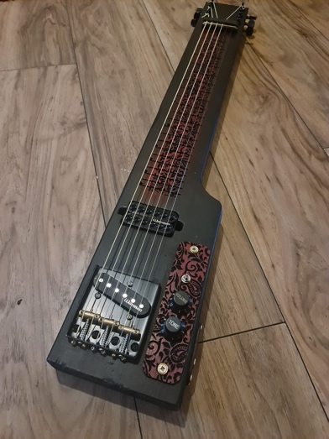
Hand made using solid timber (pine) – our lap steel guitars can be customised using engraving techniques and paint / varnish finishes. We can also provide a variety of scale and string numbers using either traditional guitar hardware or unique ‘found objects’ (bolts / handles etc !)
Bass Guitars
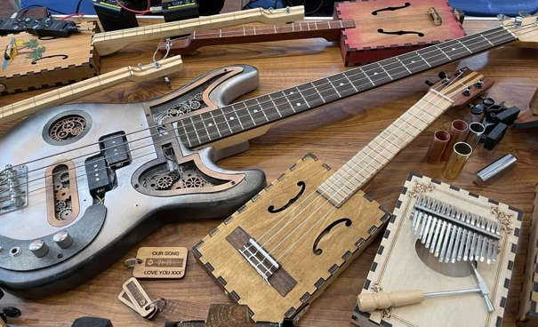
As all our guitars are custom produced and hand made we can obviously apply all guitar builds to produce bass versions too !

Guitar Options for custom builds

Number of strings
- 1
- 2
- 3
- 4
- 5
- 6
- Other …………………
Type of box
- Traditional Cigar Box
- Box Style
- Lap Steel
- Other ………………….
Type of bridge
- Telecaster Style
- Adjustable metal bridge
- Adjustable wood bridge
- Simple wood bridge
Type of neck
- Single wood
- 3 laminate
- 5 laminate
- Offset Headstock
- Scarf joint
Fretting
- Fretted
- Fretless
- Dulcimer Fretting
- Dulcimer Frettless
- Markers ……………………….

Pickups
- Single Coil
- Humbucker
- Piezo
- Switched
- Tone
- Volume
Hardware
- Gold
- Silver
- Black
- Antique

NOTES
…………………………………………….
…………………………………………….
…………………………………………….
…………………………………………….
…………………………………………….
…………………………………………….
…………………………………………….
…………………………………………….
…………………………………………….
…………………………………………….

Lets play a simple riff based song !

WILD THING

A. D. E.

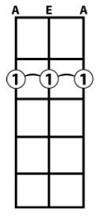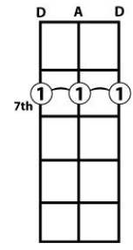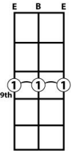

A Chord can be played at the 2nd Fret (GDG tuned)
D Chord can be played at the 7nd Fret (GDG tuned)
E Chord can be played at the 9nd Fret (GDG tuned)
So to play the above song we would strum :
RIFF 1
A. A. D. D E E D. D.
2----------2--------7—7------------9-------------9------------7---7--
2----------2--------7—7------------9-------------9------------7---7--
2----------2--------7—7------------9-------------9------------7---7---

RIFF 2
A. A. D. D E E. E. E G. A. G. A
2----------2--------7—7------------9-----9------9--9-----------0---2---0---2
2----------2--------7—7------------9-----9------9--9-----------0---2---0---2
2----------2--------7—7------------9-----9------9--9-----------0---2---0---2

OMD - Maid Of Orleans (Key of G - 3 string GDG)

G D C

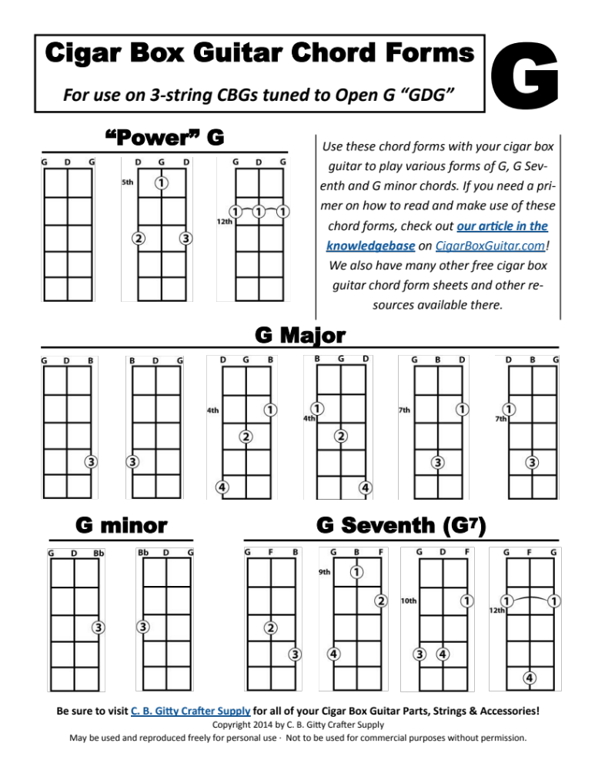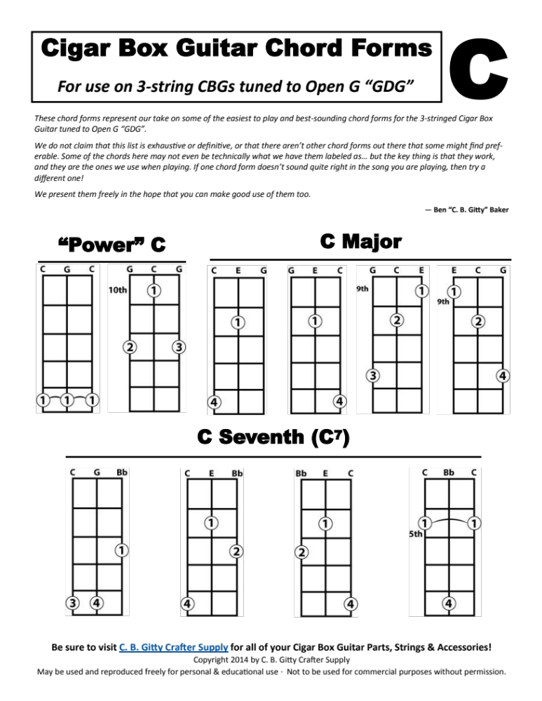

G D
If Joan of Arc had a heart
C. G
Would she give it as a gift
G. D
To such as me who longs to see
C G
how an angel ought to be

G 4—7—4—2—4-----0----------0-----
D -----------0----------2-----0--
G ----------------5--------------

G 4—7—4—2—4-----0-------5--4--0--
D -----------0-------------------
G -----------------5-------------

U2 - With or Without You (Key of G - 3 String GDG)

Bass Line

G -----------------------------------------
D -----------------------------------------
G 12-12-12-12-12-12-12-12-7…………-9………-5……………

Delay bit

G --7---7---7---7---7---7---7---7---
D 5---5---5---5---5---5---5---5---5-
G ----------------------------------

Melody

See the …………..

G 0-2-4-2-0-2-4-----4-4-4-2-0-2-0------0-7--------
D -------------------------------------------0-2—-
G ------------------------------------------------

With or without you

G ---2--2--4--2—0---
D ------------------
G ------------------

I can’t live

G ----0--2--4--
D -------------
G -------------

With our without you oh oh

G ---2—2---7—5--4--2--0--
D -----------------------
G -----------------------

Zombie. (E Minor on 4 string DADG)

Bass

G --------------------------------------------------------------------
D --------------------------------------------------------------------
A -------------------3-3-3-3-3-3-5-3----------------------------------
D -2-2-2-2-2-2-4-2-------------------5-5-5-5-5-5–7-5---4-4-4-4-4-4–6-4

Pads

G -------------------------------
D --2------10------5------4------
A -------------------------------
D -------------------------------

Chords

G --0----0----0----2---
D --2----2----0----0---
A --2----3----5----0---
D --2----2----5----0---

Melody

G -----------------------------------------------------
D --2--0----------0------------------------------------
A ----------2--------3--2--0----3--2--0----------0-----
D ---------------------------------------------5----4--

G ---0-------0-----------0-------0---0-------0-------0--0--2-----
D -4---2---4---2----2--4----2--4-------4--0----4--0-----------4--
A ---------------------------------------------------------------
D ---------------------------------------------------------------

G ---------0--------2-0-2-0-----------------------------------------
D -4--4--4----2---4---------2---2--4--0---2--4--0---2--4--4--4--4(2)
A ------------------------------------------------------------------
D ------------------------------------------------------------------

Purple Rain (3 string GDG)

Chord Progression:

G Em D C

G --------0-----0-----2-----5
D --------0-----2-----0-----5
G --------0-----4-----2-----5

Scale to Play over it !

 | Power Chord | Major | Minor
A | 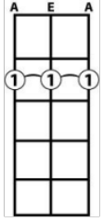 | 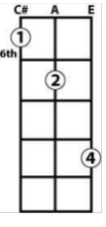 | 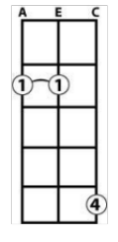
Bb | 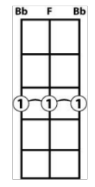 | 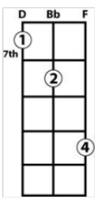 | 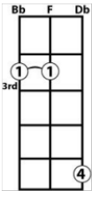
B | 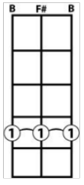 | 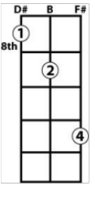 | 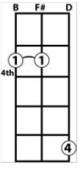
C | 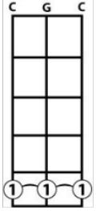 | 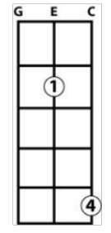 | 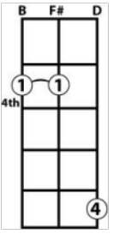  5
Db | 6th | 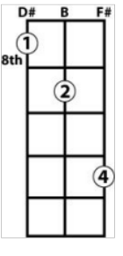  10th | 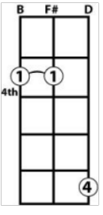  6
D | 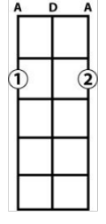 | 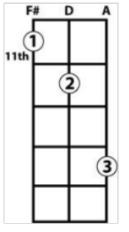 | 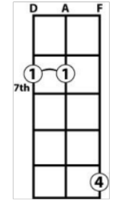
Eb | 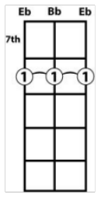  8th | 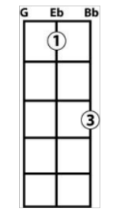 | 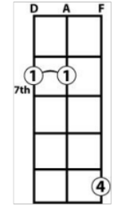  8th
E | 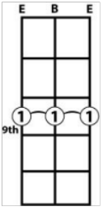 | 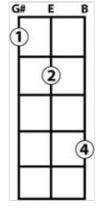 | 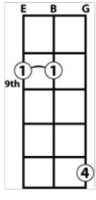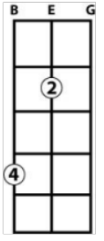
F | 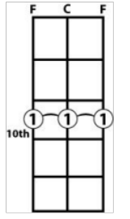 | 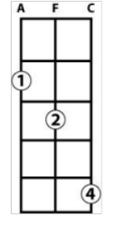 | 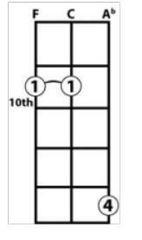
Gb | 11th | 3rd | 11th
G | 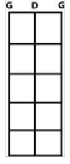 | 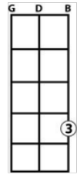 | 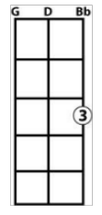

Twinkle Twinkle Little Star

|-0--0--7--7--9--9--7-----|-5--5--4--4--2--2--0-----|

|-7--7--5--5--4--4--2-----|-7--7--5--5--4--4--2-----|

|-0--0--7--7--9--9--7-----|-5--5--4--4--2--2--0-----|

